Airfoil Selection Tool Development Using CRISP-DM Process

Mitchell Scott *Data Analytics Certificate Program  
Graduate School of Engineering and Management  
Air Force Institute of Technology*Wright-Patterson AFB, OH*mitchell.scott.7@us.af.mil*

Paul Auclair  
*Data Analytics Certificate Program  
Graduate School of Engineering and Management  
Air Force Institute of Technology*Wright-Patterson AFB, OH  
[paul.auclair.1.ctr@us.af.mil](mailto:paul.auclair.1.ctr@us.af.mil)

Torrey Wagner  
*Data Analytics Certificate Program  
Graduate School of Engineering and Management  
Air Force Institute of Technology*  
Wright-Patterson AFB, OH  
[torrey.wagner@afit.edu](mailto:torrey.wagner@afit.edu)

Brent Langhals  
*Data Analytics Certificate Program  
Graduate School of Engineering and Management  
Air Force Institute of Technology*  
Wright-Patterson AFB, OH  
[brent.langhals@afit.edu](mailto:brent.langhals@afit.edu)

**Abstract—** **The Airfoil Selection Tool Development Project aims to streamline the process of selecting airfoils based on geometric and aerodynamic characteristics. This project integrates an extensive airfoil database with automated preprocessing routines to standardize and analyze airfoil geometries. The tool employs XFOIL to generate aerodynamic coefficients for a broad range of airfoils, enabling engineers to make informed design choices efficiently. A robust graphical user interface (GUI) facilitates user interaction, allowing airfoil selection based on performance criteria or geometric similarity. Comparative validation against experimental and high-fidelity CFD benchmark data confirmed the tool's predictive reliability within XFOIL’s operational envelope. Despite some discrepancies in drag prediction at high lift coefficients, the tool effectively supports airfoil selection for preliminary aircraft design. Future enhancements include integrating higher-fidelity aerodynamic solvers, expanding the airfoil database, and refining geometric analysis capabilities.**

***Keywords — Airfoil Selection, Aerodynamics, CRISP-DM, Data Analysis, XFOIL, Aircraft Design, Computational Fluid Dynamics (CFD), UIUC Airfoil Coordinates Database, Open-Source Software, Engineering Tool Development.***

### I. Introduction & Background

Airfoil selection is a foundational aspect of aircraft design, directly influencing lift, drag, and overall aerodynamic performance. An airfoil's shape dictates how air flows around it, generating the force that allows an aircraft to fly. The process of choosing the right airfoil is complex, requiring engineers to balance multiple, often conflicting, design objectives. These objectives can include maximizing lift-to-drag ratio for fuel efficiency, achieving specific stall characteristics for safety, or meeting structural requirements for weight and durability.

The evolution of airfoil design has a rich history, with early pioneers relying on empirical methods and wind tunnel testing. Early airfoils were often based on simple geometric shapes, but over time, designers developed more sophisticated profiles to improve performance. The development of computational fluid dynamics (CFD) has revolutionized airfoil design, enabling engineers to analyze and optimize airfoil shapes with greater precision. However, even with advanced tools, the initial selection of candidate airfoils remains a critical step, often involving the consultation of extensive databases and the use of specialized software.

The UIUC Airfoil Coordinates Database, a widely used resource in the aerospace community, provides a comprehensive collection of airfoil geometries, serving as a valuable starting point for many design projects [1]. Tools like XFOIL have become indispensable for analyzing airfoil performance, allowing engineers to quickly evaluate the aerodynamic characteristics of different shapes [2, 3]. Figure 1 shows the airfoil E171 taken from the UIUC Database.

Figure 1: E171 Airfoil Image Taken From UIUC Database

Developed by Mark Drela at the Massachusetts Institute of Technology (MIT), XFOIL is an open-source panel method-based solver for analyzing subsonic airfoil performance. It provides inviscid flow solutions coupled with a boundary layer model to estimate lift, drag, and moment coefficients. Due to its computational efficiency and ease of use, XFOIL has become a widely used tool for preliminary airfoil analysis and optimization in both academia and industry [3].

This project aims to address the challenges in airfoil selection by developing a tool that provides a comprehensive database of common airfoil designs and calculates their aerodynamic characteristics. The tool utilizes the UIUC Airfoil Coordinates Database as the primary source for airfoil geometry data and employs open-source software like XFOIL for aerodynamic analysis. It is designed to enable users to input either target aerodynamic performance parameters or a point cloud defining a desired airfoil shape and then identify the closest matching airfoil(s) from the database.

The selection of an optimal airfoil represents a critical, multi-variable optimization problem early in the aircraft design cycle, profoundly influencing flight performance, efficiency, and structural considerations. Historically, this process involved manual searches through extensive catalogues (like the UIUC Database) and iterative, often time-consuming, analyses using tools ranging from empirical methods to CFD The advent of accessible computational power and open-source tools like XFOIL presented an opportunity to automate and streamline significant portions of this workflow [3].

The CRISP-DM is a structured methodology for handling data-driven projects. It consists of six key phases (shown in Figure 2): business understanding, data understanding, data preparation, modeling, evaluation, and deployment. By following this framework, the development of the Airfoil Selection Tool ensures a systematic approach to data acquisition, processing, and result interpretation, enhancing reproducibility and usability [4].

Figure 2: CRISP-DM Framework

This project strategically leverages these advancements to create a dedicated Airfoil Selection Tool. The decision to adopt the CRISP-DM framework provides a rigorous, industry-standard methodology for managing the data lifecycle – from acquisition and understanding (sourcing airfoil coordinates, understanding XFOIL's requirements and limitations) through preparation (formatting data), modeling (running XFOIL simulations), evaluation (comparing results), and deployment (creating the usable tool). This systematic approach ensures reproducibility and traceability. Figure 1 shows the CRISP-DM framework. By deliberately choosing open-source software (XFOIL) and publicly available data (UIUC Database), the project minimizes direct costs, making the primary investment the specialized personnel time required for data integration, analysis scripting, and tool development. The anticipated benefits extend beyond mere time savings; the tool empowers engineers to explore a wider design space, potentially uncovering non-intuitive airfoil choices that yield superior performance and facilitates rapid sensitivity studies early in the design phase where changes have the most impact and lowest cost. The capability to search by performance metrics or geometric shape caters to different design scenarios, from clean-sheet designs to modifications requiring matching existing wing interfaces.

### II. Method

The development of the Airfoil Selection Tool was systematically guided by the CRISP-DM, ensuring a structured and iterative approach. This framework facilitated managing the project from initial data sourcing through to the evaluation of the final tool.

#### Data Acquisition

The primary data source for this project was the UIUC Airfoil Coordinates Database, a widely recognized and comprehensive collection of airfoil geometries used extensively in the aerospace community [1].

The acquisition of airfoil data involved programmatic downloading of coordinate files, which are typically stored in plain text .dat format. A custom script, developed using Python 3.12, Selenium 4.29, and BeautifulSoup 4.13, was used to automate the extraction of airfoil names, point cloud data (.dat files), and associated descriptive information from the website.

The web scraping process targeted all airfoils with associated '.dat' files, resulting in the collection of 1604 airfoils. Initial checks were performed to verify file integrity and identify any missing data, and duplicate entries. Figure 3 shows a quick comparison of the downloaded point cloud compared to the available image on the UIUC webpage [1].

Figure 3: Side-by-Side Comparison of GOE229 Captured Point Cloud vs Point Cloud from UIUC Website

To facilitate efficient data management and integration with XFOIL, a custom Python-based SQL database was created. This database stores the extracted airfoil data, including:

* Airfoil name (primary key)
* Point cloud data (.dat file contents, stored as ASCII text)
* Descriptive information taken from the website
* Geometry-based grouping identifiers (thickness, chord, etc.)

The geometry-based grouping identifiers were derived from the descriptive information and initial analysis of the point cloud data. These groupings are intended to support subsequent analysis and modeling, particularly for predicting aerodynamic coefficients using XFOIL. The .dat files are stored in a manner that allows for direct retrieval and processing by XFOIL [3]. The web scraping was conducted in accordance with the UIUC Airfoil Data Site's terms of service.

#### Data Understanding

This phase involved in-depth exploration of both the acquired geometric data and the chosen aerodynamic prediction tool, XFOIL [2]. Analysis of the .dat files revealed variations in formatting, coordinate density, point ordering (clockwise vs. counterclockwise), and the representation of leading and trailing edges. Critically, a significant variation in the number of coordinate points used to define each airfoil profile was observed across the database, ranging from fewer than 50 points for some older profiles to several hundred for others. This inconsistency in point cloud density presented challenges for automated analysis. Some files required inspection to confirm coordinate system and units (implicitly dimensionless, normalized by chord).

Figure 4: Histogram of Point Cloud Densities

Beyond basic format checking, significant effort was dedicated to understanding the geometric characteristics inherent in the airfoil database. The variable point density directly impacted the fidelity and reliability of automated geometric parameter calculations. For instance, accurately estimating the Leading-Edge Radius (LER) is highly sensitive to the density and distribution of points near the leading edge; sparsely defined profiles could lead to inaccurate LER estimations. Python Routines were developed to automatically calculate key geometric parameters directly from the standardized coordinate data for each airfoil where possible, including:

* Maximum Thickness and Location: Calculating the maximum vertical distance between the upper and lower surfaces and its chordwise position.
* Maximum Camber and Location: Determining the maximum deviation of the mean camber line from the chord line and its chordwise position.
* Leading Edge Radius (LER): Estimating the radius of curvature at the leading edge, a critical parameter influencing stall characteristics and aerodynamic performance.
* Trailing Edge Angle: Measuring the included angle at the trailing edge, relevant for drag characteristics.

Furthermore, classifying the airfoils into meaningful groups was essential for managing the database and interpreting results. A multi-pronged classification approach was employed:

1. Family/Series Identification: Where possible, airfoils were classified based on their known family or series designation, often derivable from the filename (e.g., NACA 4-digit, NACA 6-series, Wortmann FX-, Eppler E-). This leverages existing aerodynamic knowledge associated with these series. Figure 5 shows a pie chart of this data automatically determined from their names/descriptions.

Figure 5: Pie Chart of Airfoil Classifications

1. Geometric Categorization: Airfoils were broadly categorized based on calculated geometric parameters:
   * Camber Groupings: Potential to create groupings based on the computed of the airfoils. Figure 6 shows a histogram of the calculated maximum camber of the airfoils.
   * Thickness Categories: Grouping based on maximum thickness (e.g., thin <10%, moderate 10-15%, thick >15%).

Figure 6: Histogram of Maximum Calculated Camber

Understanding these geometric features, classifications, and the implications of variable point density was crucial not only for database organization but also for informing the subsequent XFOIL modeling strategy. For example, knowing an airfoil's thickness, leading-edge radius, and point density helps anticipate its potential stall behavior and guides the selection of appropriate XFOIL simulation parameters (e.g., panel density settings, iteration limits) and potential data preparation steps (like re-paneling, discussed next) for robust convergence.

Simultaneously, XFOIL's operational principles and limitations were thoroughly reviewed. As a potential flow solver incorporating a panel method coupled with an integral boundary layer formulation, its strengths lie in rapid prediction of attached flow conditions typical of cruise flight. Key input parameters were identified: airfoil coordinate file, Reynolds number (Re), and a range of angles of attack (α). Understanding XFOIL's sensitivity to coordinate point density and smoothness, particularly near the leading edge (informed by the LER analysis), was critical. Furthermore, its known limitations in accurately modeling extensive flow separation, shock-boundary layer interaction (relevant at higher Mach numbers), and complex 3D effects guided the scope of the tool's intended application and the subsequent evaluation strategy. A preliminary sensitivity analysis was conducted on a sample airfoil (e.g., NACA 0012) to determine suitable XFOIL operational parameters (e.g., panel density settings, iteration limits) for batch processing [2].

#### Data Preparation

This phase focused on preparing the acquired data for subsequent analysis and modeling. Key tasks included data cleaning, formatting, and standardization. The primary goal was to transform the raw data into a suitable format for use with the XFOIL aerodynamic analysis tool and to ensure consistency across the dataset.

A significant challenge encountered during this phase was the inconsistency in point cloud formatting within the dataset. Analysis of the .dat files revealed variations in:

* Coordinate density (number of points defining each airfoil)
* Point ordering (clockwise vs. counterclockwise)
* Representation of leading and trailing edges

Specifically, two primary point cloud ordering conventions were observed:

* Convention 1: Points are ordered starting at the leading edge (LE), proceeding along the suction surface to the trailing edge (TE), and then along the pressure surface back to the LE.
* Convention 2: Points are ordered starting at the LE, proceeding along the suction surface to the TE, and then starting again at the LE, proceeding along the pressure surface to the TE. Figure 7 shows this problem captured in a plot of the point cloud.

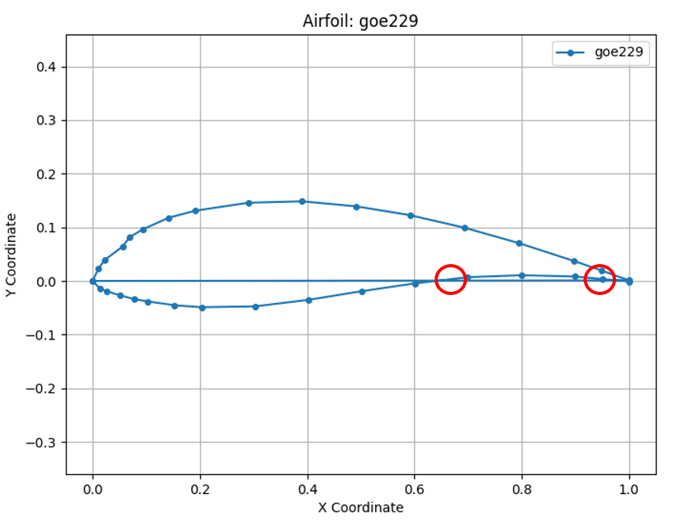

Figure 7: GOE229 Airfoil with Point Cloud Ordering Issue

This inconsistency in point cloud ordering necessitated a data preprocessing step to standardize the data for consistent analysis and XFOIL compatibility. A custom script was developed to reformat the point cloud data, ensuring that all airfoils followed a consistent point ordering convention. This process eliminated potential self-crossing or non-self-closing issues that could arise from the inconsistent ordering.

Additionally, the number of coordinate points used to define each airfoil profile varied significantly across the database. This variation in point cloud density could impact the fidelity and reliability of automated geometric parameter calculations and aerodynamic analysis. To address this, some airfoils required resampling to achieve a consistent level of detail.

Beyond basic format checking, significant effort was dedicated to understanding the geometric characteristics inherent in the airfoil database. Python routines were developed to automatically calculate key geometric parameters directly from the standardized coordinate data for each airfoil where possible, including:

* Maximum Thickness and Location
* Maximum Camber and Location
* Leading Edge Radius (LER)
* Trailing Edge Angle

These calculated geometric parameters offered a powerful means of grouping airfoils based on their shape characteristics.

#### Modeling

The modeling phase focused on generating the core aerodynamic database necessary for the Airfoil Selection Tool. This involved utilizing the XFOIL software to predict the aerodynamic characteristics of the airfoils compiled in the data acquisition phase. Figure 8 provides a sample look at the output running XFOIL in a terminal window for A18 with a sweep of angle of attacks ().

Figure 8: XFOIL Example Results for A18

The core aerodynamic database was generated by executing XFOIL simulations in batch mode across the prepared airfoil geometries. A master script orchestrated this process:

* Parameter Definition: A standard range of angles of attack was defined, spanning from -5 degrees to 15 degrees, at 1-degree increments. The Reynolds number varied with each run where the ranges included 50,000, 200,000, 1,000,000.
* XFOIL Execution: For each airfoil, the script automatically generated the necessary input files for XFOIL, executed the simulations, and parsed the output files.
* Data Extraction: Aerodynamic coefficients, including lift coefficient ($C_{L}$), drag coefficient ($C_{D}$), and pitching moment coefficient ($C_{M}$), were extracted from the XFOIL output files.
* Database Integration: These coefficients were then incorporated into the database, linked to the corresponding airfoil geometry.

The process of automating XFOIL simulations and extracting aerodynamic data was crucial for efficiently characterizing the airfoil database. This automation enables the tool to rapidly predict and compare airfoil performance, which is a core functionality for the tool.

#### Evaluation

The predictive accuracy of the generated aerodynamic database was assessed by comparing XFOIL results against established benchmark data for well-known airfoils (e.g., NACA 4-digit series, Wortmann FX series). Benchmark data were sourced from experimental wind tunnel tests, and, where available, results from higher-fidelity CFD codes [5-7].

### III. Analysis & Results

This section details the analysis performed on the airfoil dataset, focusing on the findings that are most relevant to the development and application of the Airfoil Selection Tool.

#### Geometric Diversity Analysis:

To support the tool's ability to identify suitable airfoils across a broad range of design requirements, a detailed geometric analysis was conducted. This analysis aimed to quantify and visualize the diversity of airfoil shapes present in the dataset.

Key geometric parameters were calculated from the point cloud data, including maximum camber, maximum thickness, span, and thickness-to-chord ratio. Statistical analysis and visualizations (histograms) were used to illustrate the distribution of these parameters within the dataset. These analyses confirmed that the collected airfoils exhibit a wide spectrum of geometric properties.

The calculation of these geometric parameters also enabled a novel way to group airfoils based on their shape characteristics. A Python function was developed to query the database for airfoils that match user-specified geometric criteria (e.g., airfoils with a target thickness within a given tolerance). This grouping capability allows for efficient comparison of airfoils with similar shapes and facilitates the identification of trends related to specific geometric attributes. Figure 9 shows this capability integrated into the GUI where airfoils with a maximum thickness close to 0.3 are displayed.

Figure 9: Developed GUI Geometric Search Tab

#### XFOIL Integration

A set of airfoils, representing the geometric range of the database, were tested with XFOIL to validate the integration of the aerodynamic analysis tool. This testing confirmed that the point cloud data, after preprocessing, could be correctly ingested and processed by XFOIL to generate aerodynamic coefficient predictions.

#### Model Evaluation

The evaluation of the Airfoil Selection Tool focused on assessing its accuracy and reliability in predicting airfoil aerodynamic characteristics. This involved comparing the tool's predictions (derived from XFOIL simulations) with established benchmark data for a set of airfoils.

Plots were generated mirroring the tool's XFOIL-derived polars ( $C_{L}$ vs. $α$, $C_{D}$ vs. $α$, $C_{L}$ vs. $C_{D}$) with the benchmark data for selected airfoils and flight conditions. Figure 10 show the $C_{L}$ plots generated (left) compared to the equivalent $C_{L}$ experimental plots found [5-7].

Figure 10: NACA4412, NACA0012, and FX 63-137 Calculated $C_{L}$ with XFOIL (left) vs Experimental (right) [2-4]

Analysis of lift coefficient predictions ($C_{L}$) demonstrated good agreement with benchmark data within the expected operational envelope of XFOIL. However, drag prediction accuracy presents a more significant challenge. While the predicted minimum drag coefficient ($C_{D, min}$) often provides a reasonable estimate, XFOIL tends to underpredict the drag rise at higher lift coefficients as flow separation begins to influence the pressure distribution and viscous effects become more pronounced. Observed discrepancies of $C_{D}$ ranged up to 30% [8]. Bak et. al did propose settings in XFOIL that could potentially mitigate these discrepancies, but their recommendations have not been integrated yet [9].

#### Model Application

The Airfoil Selection Tool developed in this project is designed to provide aircraft design engineers with a powerful and efficient way to identify suitable airfoils for their specific needs. The tool addresses two common challenges in airfoil selection:

* + - 1. Performance-Driven Selection: Engineers often have target aerodynamic performance characteristics, such as desired lift and drag coefficients. The tool allows users to input these performance metrics and efficiently search the database for airfoils that meet the specified criteria. This enables engineers to quickly identify existing airfoils that satisfy their design requirements. Figure 11 shows this tab from the GUI.

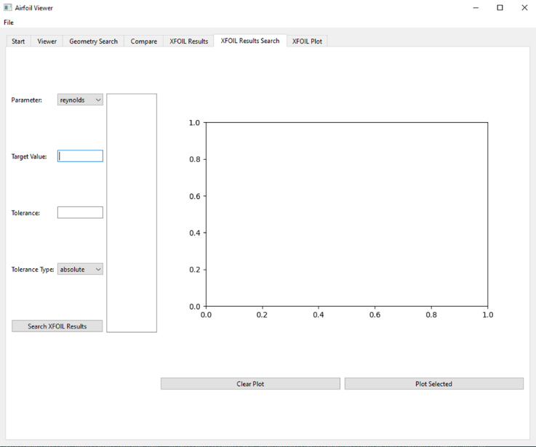

Figure 11: Developed GUI Aerodynamic Performance Based Airfoil Search Tab

* + - 1. Shape-Driven Selection: In other scenarios, engineers may have a conceptual airfoil shape and need to find the closest match among standard airfoil designs. The tool enables users to input a point cloud defining their desired shape and then compares this input to the airfoil geometries in the database to identify the closest matches. This is particularly useful for practical reasons, as using a standardized airfoil can simplify manufacturing and reduce costs. Figure 12 shows an example of this process being completed in the GUI.

Figure 12: Developed GUI Conceptual Shape to Closest Airfoil

* + - 1. Database Interaction: The tool also provides a user-friendly interface to interact with the airfoil database. Users can query the database, compare airfoil, and generate aerodynamic data for a wide range of airfoils. This capability enhances the user's ability to explore and analyze the available airfoil options. Figure 13 shows the “Viewer” tab in the GUI where users can interact with the airfoils already in the database.

Figure 13: Developed GUI Database Interaction Tab

The tool's ability to efficiently search and compare airfoils based on both performance criteria and geometric shape makes it an asset in the aircraft design process.

### IV. Conclusion

The Airfoil Selection Tool Development Project successfully achieved its primary objective of creating a functional and efficient tool for airfoil comparison and selection. This was accomplished through the structured application of the CRISP-DM framework, leveraging open-source software tools, and utilizing publicly available airfoil data. The resulting tool offers a valuable resource for aircraft design engineers, streamlining the airfoil selection process and demonstrating potential for improved aircraft designs and reduced engineering time.

The developed tool provides several key functionalities:

* Performance-Driven Selection: Users can input target aerodynamic performance characteristics (e.g., desired lift and drag coefficients) to efficiently search the database for airfoils that meet the specified criteria.
* Shape-Driven Selection: Users can input a point cloud defining a desired airfoil shape, and the tool can identify the closest matches among standard airfoil designs in the database.
* Aerodynamic Data Generation: The tool allows users to query the database, compare airfoil performance, and generate aerodynamic data for a wide range of airfoils.

The automated workflow implemented in the tool, from data acquisition and preprocessing to aerodynamic analysis and database integration, demonstrates the project's emphasis on efficiency and cost-effectiveness. The integration of data sources and computational tools streamlines the airfoil selection process, reducing the time and effort required for engineers to identify suitable airfoils for their specific applications.

The tool's aerodynamic predictions, generated using XFOIL, show reasonable agreement with benchmark data, particularly for lift coefficient predictions within the expected operational envelope. However, it's important to acknowledge the limitations in drag coefficient predictions, especially in regions of separated flow. These limitations are consistent with the use of a lower-fidelity aerodynamic prediction tool that does not fully capture complex viscous flow phenomena [3, 11].

Despite these limitations, the project has established a strong foundation for future development and enhancement. To further improve the tool's accuracy and expand its capabilities, future work should focus on several key areas:

* Enhanced Aerodynamic Modeling: Integrating a higher-fidelity aerodynamic solver, such as a viscous Computational Fluid Dynamics (CFD) code, would improve the accuracy of drag predictions and extend the tool's applicability to a wider range of flow conditions.
* Expanded Airfoil Database: Expanding the airfoil database to include a greater variety of airfoil geometries and data types would increase the tool's versatility and usefulness.
* Advanced Geometric Analysis: Incorporating more sophisticated geometric analysis capabilities, such as automated feature extraction and shape optimization tools, would further enhance the tool's ability to support airfoil selection based on geometric criteria.
* While the current tool efficiently identifies suitable airfoils using a nearest neighbor search, future iterations could integrate more advanced optimization techniques. Methods such as genetic algorithms, machine learning-based surrogate modeling, or gradient-based optimization could further refine airfoil selection by exploring a broader design space and adapting to specific performance constraints. These enhancements have not yet been implemented but represent a promising avenue for improving selection accuracy and efficiency.

In conclusion, this project has successfully developed a functional Airfoil Selection Tool that addresses key challenges in the airfoil selection process. The tool has the potential to significantly benefit aircraft design engineers by providing an efficient and effective way to identify and compare airfoils.

### References

|  |  |
| --- | --- |
| [1] | UIUC Airfoil Coordinates Database, "Airfoil Data Site," [Online]. Available:<https://m-selig.ae.illinois.edu/ads/coord_database.html>. [Accessed: 2025 February 25]. |
| [2] | XFOIL, [Online]. Available:<https://web.mit.edu/drela/Public/web/Xfoil/>. [Accessed: 2025 March 10]. |
| [3] | Drela, M. (1989). XFOIL: An Analysis and Design System for Low Reynolds Number Airfoils. AIAA Paper 1989-2186. (Drela, 1989) |
| [4] | Shearer, C. (2000). The CRISP-DM Model: The New Blueprint for Data Mining. *Journal of Data Warehousing*, 5(4), 13–22. |
| [5] | Airfoil Tools, "NACA 0012 Airfoil Data," [Online]. Available:<http://airfoiltools.com/airfoil/details?airfoil=n0012-il>. [Accessed: 2025 March 15]. |
| [6] | Airfoil Tools, "NACA 4412 Airfoil Data," [Online]. Available:<http://airfoiltools.com/airfoil/details?airfoil=naca4412-il>. [Accessed: 2025 March 15]. |
| [7] | Airfoil Tools, "FX 63-137 Airfoil Data," [Online]. Available:<http://airfoiltools.com/airfoil/details?airfoil=fx63137-il>. [Accessed: 2025 March 15]. |
| [8] | Mokry, M., & van Rooij, R. (2017). Accuracy of XFOIL in Predicting Airfoil Characteristics for Wind Turbine Applications. *Journal of Aircraft*, 54(6), 2253-2262. https://doi.org/10.2514/1.C033788 (Mokry & van Rooij, 2017) |
| [9] | Bak, C., & Zahle, F. (2011). XFOIL Predictions for Wind Turbine Airfoils at Low Reynolds Numbers. Wind Energy, 14(7), 995-1010. https://doi.org/10.1002/we.2174 (Bak & Zahle, 2011) |
| [10] | Shearer, C. (2000). The CRISP-DM Model: The New Blueprint for Data Mining. *Journal of Data Warehousing*, 5(4), 13–22. |
| [11] | Selig, M. S., et al. (1995). Summary of Low-Speed Airfoil Data. SoarTech Publications. |